Auto-focusing Modes

Notes compiled by Tony Smith

Introduction
Today’s digital cameras have sophisticated auto-focusing (AF) systems that are designed to ensure that our images are in focus. Most AF systems in today’s cameras are known as ‘passive’ autofocus and work in one of two ways.

Contrast Detection Autofocus
This is the least complex of AF systems and is most prevalent in compact cameras, newer dSLR cameras when used in ‘Live View’ and video cameras. Here, the sensor itself is used to perform autofocus. It uses the sensor to detect at which point the lens produces an image with the highest level of contrasting pixels. This indicates the lens is sharply focused. An in-focus black and white stripe will have higher contrasting pixels than an out-of-focus stripe, which will appear more grey. A disadvantage to contrast AF is that it cannot gauge whether the camera lens is front or back focused-- just that it is out of focus. This is primarily why it has to be used iteratively; contrast measurements using at least two lens positions are needed to assess which direction the camera should be focusing (i.e., in front or in back of where it was previously focusing). The contrast detection is generally more fail proof (if given lots of light and enough time to focus) since it not reliant on pre-calibration.
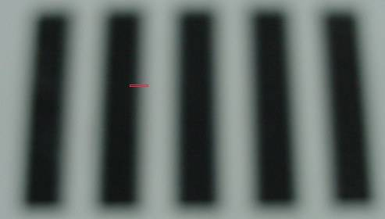

Phase detection
This more complex AF system is used on sophisticated compacts, bridge cameras, compact system cameras and dSLRs. Known as ‘phase detection’, light from the scene is split into two from different parts of the lens. These parts are compared by the AF sensor, which will direct the AF servos (tiny electrical motors) to make adjustments to the lens, depending on the similarity in light patterns between the two images.

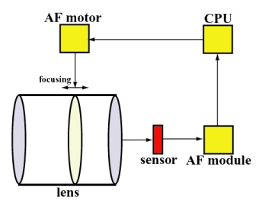
Unlike basic compact cameras, which have a single autofocus (AF) point that will focus the lens only on the central part of the scene, dSLRs and other more sophisticated cameras have a number of selectable AF points placed around the viewfinder frame. My Nikon D90 has 11 sensor points, one of which is a cross-sensor in the central area (this detects vertical and horizontal lines). The latest Nikon D7100 dSLR has a 51-point AF system (with 15 cross-sensors in the central area). By analysing the signal from each of the AF sensors, this system can adjust the lens to the point at which the highest-contrast image is achieved. If more than one AF point is being used, the system assumes that you want to focus on the point that gives the closest focusing distance (note, this can be a problem if your subject of interest in not closest to the camera – see the section on ‘single point’ focus below).

As for accuracy, generally, if used correctly, AF systems are very accurate (Passive Phase Detection being the most accurate). However, they often have problems in low-light (hence the AF lamp that comes on when you try and focus in the dark). The user also has to make sure that they are focusing on the correct point (e.g. focusing on the subject not the background).

Single AF (one Shot/Single Shot) and Continuous AF
Many cameras have two AF settings – Single AF and Continuous AF. Single AF should be used when the subject is relatively still, such as landscapes or portraits. Pressing the shutter release halfway will set the focus, and the camera will go on to take a picture if it achieves focus and the shutter release is fully pressed. In Continuous Focus mode, pressing the shutter release half way will cause the camera to lock onto the subject and continuously keep it in focus until the shutter is fired. This makes a continuous AF mode useful for taking photos of moving subjects, such as children, sports, etc. When you use this mode, you should try to follow the subject through the viewfinder or on the rear LCD screen and the camera will attempt to keep it in focus until you want to take the photo.

Choosing where your camera focuses
How often have you been disappointed that the camera has not focused on the spot that you wish to be in focus? For instance, it may have focused on the background instead of the object of interest. There are two ways to take control of the focusing. The first and most obvious way is to focus manually. This choice is commonly not available with compact cameras. If you are lucky enough to have a camera with manual focus facility, then it can be extremely useful. You will have to switch off the AF option on your camera, and if you have interchangeable lenses, switch to manual setting on the lens. Manual focus is often preferable in macro photography.

The other way we can determine what the camera is focusing on is to be aware of where in the scene the AF system has locked focus. If you are using multiple focus points, the point or points that have achieved focus will light up in the viewfinder. Are these the focus points where you want to achieve focus? As stated above, the camera will lock focus on the nearest object to the camera. A better alternative is to switch to ‘single point’ focus. This works very well with static subjects. The single focus point may be in the middle of the viewfinder or, in advanced cameras, it may be moved around the frame (see you camera manual). If the object of interest is moving, however, it is better to use continuous AF.

Focusing problems
The photographic subject can have an enormous impact on how well your camera autofocuses—and often even more so than any variation between camera models, lenses or focus settings. The three most important factors influencing autofocus are:
- light level
- subject contrast
- camera or subject motion
At low light levels the AF system may struggle to lock focus. See if you can locate a high contrast area within the scene and focus on that. Your camera will often turn on the AF lamp to illuminate the scene. This will only help with objects close by.
If you attempt to focus on a scene with low contrast, such as a single colour tone, the AF system will again struggle to lock on.
Note that each of these factors are not independent; in other words, one may be able to achieve autofocus even for a dimly lit subject if that same subject also has extreme contrast, or vice versa. This has an important implication for your choice of autofocus point: selecting a focus point which corresponds to a sharp edge or pronounced texture can achieve better autofocus, assuming all other factors remain equal.
AF lock
Your camera may posses an AF lock button. Usually, this button will also lock exposure as well. Therefore, the button may be labelled AE/AF. To use this facility, half press the camera shutter release to activate the AF system and then press AE/AF button. While this button is held down, the focus will be locked. When the shutter is released, the focus will be unlocked. Do read your camera manual to see how this facility may be used.

